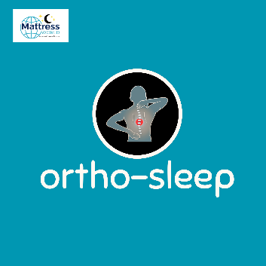
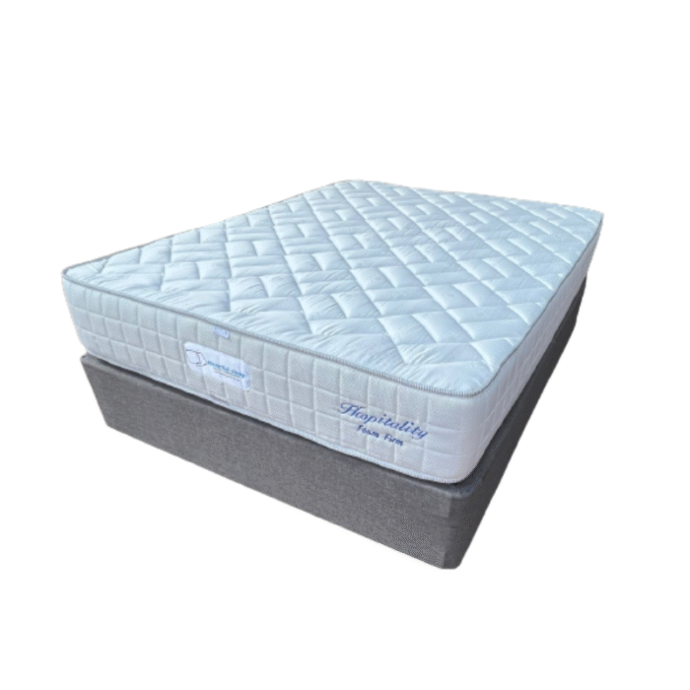

Model : Hospitality-Foam Firm 150 Bed Set
Supplier/Manufacturer : Mattress World
Range : Ortho Sleep Range – All Ortho Sleep Range Mattresses are Orthopedic Design. Made stronger to help improve posture, better quality than average mattresses and keep their shape and feel for a longer period of time. Great quality and good for back support.
Features :
- Hospitality Grade Quality
- Heavy Duty Support Foam Core
- High Density, Firm Feel Orthopedic Comfort Foam
- Turnable Design
- Multi Layered Foam
- 150kg Per Person Per Side
- 2 Year Guarantee
- 15 Year Warranty
- Firm Feel
Prices – Bed Set :
- Single Bed Set – R5499
- Three Quarter Bed Set – R5999
- Double Bed Set – R8499
- Queen Bed Set – R8499
- King Bed Set – R10499
- Super King Bed Set - R15999
Prices – Mattress Only :
- Single Mattress Only – R4999
- Three Quarter Mattress Only – R5499
- Double Mattress Only – R7999
- Queen Mattress Only – R7999
- King Mattress Only – R9499
- Super King Mattress Only - R13999
Prices - Extra Length Bed Set :
- Single Extra Length Bed Set – R6599
- Three Quarter Extra Length Bed Set – R7199
- Double Extra Length Bed Set – R10199
- Queen Extra Length Bed Set – R10199
- King Extra Length Bed Set – R12599
Prices - Extra Length Mattress Only :
- Single Extra Length Mattress Only – R5999
- Three Quarter Extra Length Mattress Only – R6599
- Double Extra Length Mattress Only – R9599
- Queen Extra Length Mattress Only – R9599
- King Extra Length Mattress Only – R11399

